**CREDIT CARD SPENDINGS SQL QUERIES**

***# Basic Data Exploration***

1. First & Last day of transaction in the database

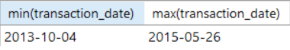

1. Types of Credit cards

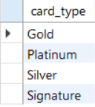

1. Types of spending through Credit Card

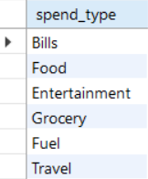

***# Data Analysis using multiple cases***

1. Write a query to print top 5 cities with highest spends and their percentage contribution of total credit card spends.

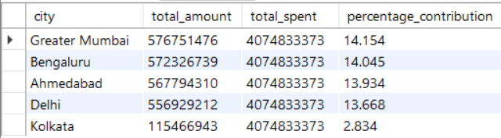

1. Write a query to print highest spend month and amount spent in that month for each card type.

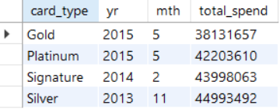

1. Write a query to print the transaction details(all columns from the table) for each card type when it reaches a cumulative of 1000000 total spends(We should have 4 rows in the o/p one for each card type).

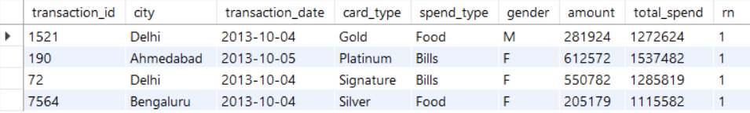

1. Write a query to find city which had lowest percentage spend for gold card type.

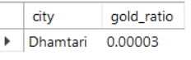

1. Write a query to print 3 columns: city, highest_expense_type , lowest_expense_type (example format : Delhi , bills, Fuel).

|  |  |  |
| --- | --- | --- |
| **city** | **highest_exp_type** | **lowest_exp_type** |
| Achalpur | Grocery | Entertainment |
| Adilabad | Bills | Food |
| Adityapur | Food | Grocery |
| Adoni | Bills | Entertainment |
| Adoor | Fuel | Bills |

<><><><><><><><><><><><><><><><><><><><><><><><><><><><>

|  |  |  |
| --- | --- | --- |
| Zaidpur | Food | Bills |
| Zamania | Entertainment | Fuel |
| Zira | Entertainment | Grocery |
| Zirakpur | Fuel | Entertainment |
| Zunheboto | Grocery | Entertainment |

1. Write a query to find percentage contribution of spends by females for each expense type.

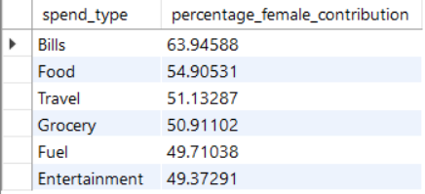

1. Which card and expense type combination saw highest month over month growth in Jan-2014.

|  |  |  |  |  |  |  |
| --- | --- | --- | --- | --- | --- | --- |
| card_type | spend_type | yr | mth | total_spend | prev_month_spend | MoM_growth |
| Gold | Travel | 2014 | 1 | 2092554 | 1113534 | 87.92008 |
| Platinum | Grocery | 2014 | 1 | 12256343 | 7757562 | 57.9922 |
| Silver | Travel | 2014 | 1 | 1170975 | 810826 | 44.41754 |
| Gold | Fuel | 2014 | 1 | 12281691 | 9570035 | 28.33486 |
| Gold | Food | 2014 | 1 | 11511990 | 9573474 | 20.24883 |
| Gold | Entertainment | 2014 | 1 | 9940137 | 8521114 | 16.65302 |
| Platinum | Bills | 2014 | 1 | 12138233 | 11134282 | 9.01676 |
| Gold | Bills | 2014 | 1 | 11137964 | 10289023 | 8.25094 |
| Platinum | Fuel | 2014 | 1 | 10698936 | 9940343 | 7.63146 |
| Silver | Fuel | 2014 | 1 | 12614488 | 11823131 | 6.69329 |
| Silver | Food | 2014 | 1 | 10019659 | 9487253 | 5.6118 |
| Platinum | Entertainment | 2014 | 1 | 9303489 | 9442901 | -1.47637 |
| Silver | Bills | 2014 | 1 | 10458449 | 11522251 | -9.23259 |
| Signature | Food | 2014 | 1 | 9655792 | 10956523 | -11.87175 |
| Gold | Grocery | 2014 | 1 | 7726804 | 8910512 | -13.2844 |
| Silver | Grocery | 2014 | 1 | 9728433 | 11367575 | -14.41945 |
| Platinum | Food | 2014 | 1 | 10090531 | 12060595 | -16.33472 |
| Signature | Fuel | 2014 | 1 | 8374754 | 10106706 | -17.13666 |
| Signature | Entertainment | 2014 | 1 | 8669623 | 10657529 | -18.6526 |
| Signature | Grocery | 2014 | 1 | 9066931 | 11699280 | -22.50009 |
| Silver | Entertainment | 2014 | 1 | 7888949 | 10387931 | -24.05659 |
| Signature | Bills | 2014 | 1 | 9529821 | 13191926 | -27.7602 |
| Signature | Travel | 2014 | 1 | 847777 | 2187558 | -61.24551 |
| Platinum | Travel | 2014 | 1 | 446659 | 1755965 | -74.56333 |

1. During weekends which city has highest total spend to total no of transcations ratio.

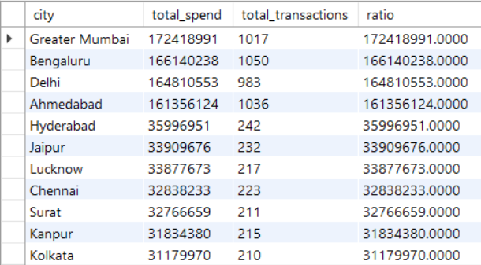

1. Which city took least number of days to reach its 500th transaction after the first transaction in that city.

